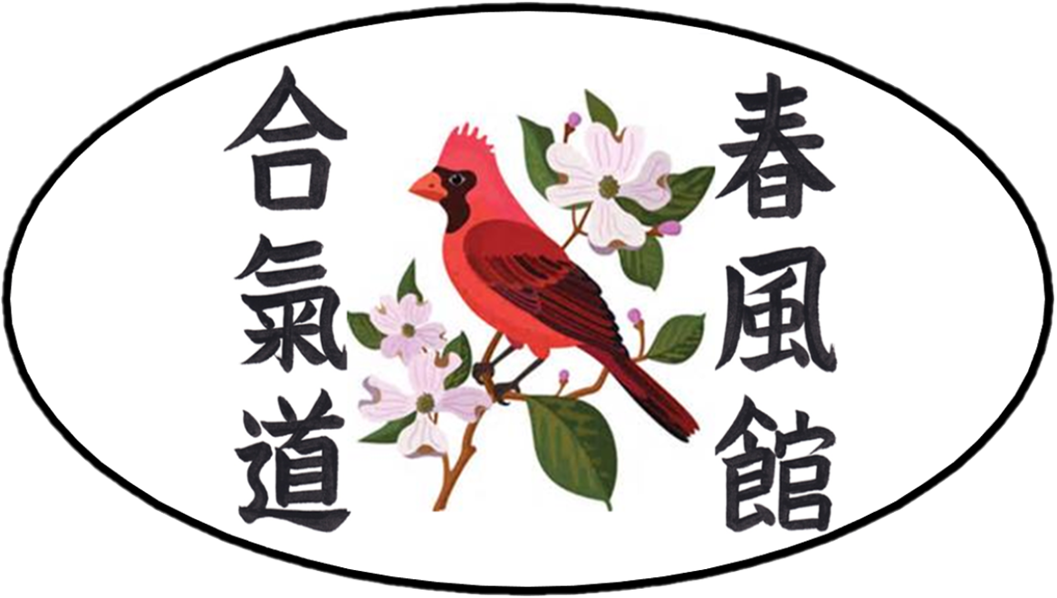
Welcome to the Independence High School Aikido Club
Aikido is a traditional Japanese martial art that emphasizes discipline, respect, and self-confidence. Unlike competitive sports, Aikido focuses on cooperation, safety, and personal growth. Students of all ages and abilities can participate — it is a lifelong practice that builds both body and mind.
Joining the Independence High School Aikido Club means becoming part of a supportive team where students will learn focus, respect, and confidence while practicing a unique martial art.
What is Shunpookan Aikido?
Shunpookan Aikido is part of an international system affiliated with the original Aikido Hombu Dojo in Tokyo, Japan — the international headquarters for worldwide Aikido. This connection means our students learn authentic, traditional Aikido as it is practiced globally.
Why Aikido?
Students and parents often ask what makes Aikido different from other martial arts. Here are a few key reasons:
• Confidence & Focus – Students learn to stay calm, think clearly, and respond effectively.
• Non-Violent Approach – Aikido teaches how to redirect conflict without relying on punches or kicks.
• Respect & Discipline – Every class begins and ends with courtesy, reinforcing values of respect.
• Teamwork & Community – Students work together, not against each other, creating a supportive environment.
• Lifelong Practice – Aikido can be practiced from childhood through advanced age.
Ranking System
Unlike many martial arts, Aikido does not use a colored belt system. Instead, we follow the Kyu/Dan ranking system:
• Kyu Ranks (White Belt): Beginner levels, numbered 6th down to 1st.
• Dan Ranks (Black Belt): Advanced levels, beginning with 1st Dan and continuing to 8th Dan.
Reaching 1st Dan (black belt) typically takes 4–8 years of steady training.
Clothing for Practice
Students do not need to purchase a martial arts uniform to participate in the Independence High School Aikido Club. Any durable, loose-fitting clothing is fine, such as:
• Sweatpants, track pants, or other athletic pants (recommended).
• T-shirts, long-sleeve athletic tops, or sweatshirts.
Important notes:
• Clothing may get stretched or torn during training, so please wear durable items that are not delicate or expensive.
• Shorts are not encouraged, since much of Aikido involves kneeling on the mat. Long pants help protect the knees.
• Jewelry should be removed before class for safety.
Safety and Physical Limitations
• Aikido training is cooperative and carefully supervised — students practice with partners, not against opponents.
• Safety is always the first priority. Falls and techniques are taught gradually and responsibly.
• Students with serious joint or back issues may not be able to participate. If a student has any injury or limitation, they should talk to the instructor before class.
Frequently Asked Questions (FAQ)
Is Aikido safe for teenagers?
Yes. Classes are designed to be safe, cooperative, and supervised at all times. Students are taught gradually and with care.
Do students have to compete?
No. Aikido is not a sport. There are no tournaments or competitions — the focus is on learning, improving, and supporting one another.
How does testing work?
Students may test for Kyu ranks as they gain experience. Progress is based on consistent practice and learning, not on speed or competition.
Who leads the club?
The Independence High School Aikido Club is led by Mr. Gilbert, a 4th-degree black belt (Yondan), certified instructor (Shidoin), and head of Shunpookan Aikido USA.
Aikido Culture
Aikido is more than just a martial art — it is a way of learning respect, patience, and responsibility. Students are expected to:
• Show courtesy to instructors and peers.
• Train with focus and effort.
• Take responsibility for their own safety and the safety of others.
This spirit of respect and care is what makes Aikido a valuable and lifelong practice.
Contact Information
Independence High School Aikido Club
Instructor: Mr. Daniel Gilbert
📧 Email: danielj.gilbert@cms.k12.nc.us
🌐 Website: www.spkusa.com
Note: The website includes information about the adult program, which covers additional areas such as self-defense applications and traditional weapons training. The high school Aikido Club focuses only on the traditional student syllabus — emphasizing movement, discipline, and respect. A dedicated high school page will be available soon.

Appendix: Basic Aikido Etiquette
• Bow when entering and leaving the dojo (practice area).
• Show respect to instructors and training partners.
• Keep uniforms/clothing clean and neat.
• Remove shoes before stepping on the mat.
• Do not wear jewelry or watches during practice.
• Listen carefully and follow instructions the first time they are given.
• Train with focus, but never with aggression.
• Always ensure the safety of your partner.

